**PROJECT 3**

**Linux1 – Ip address: 100.25.161.72**

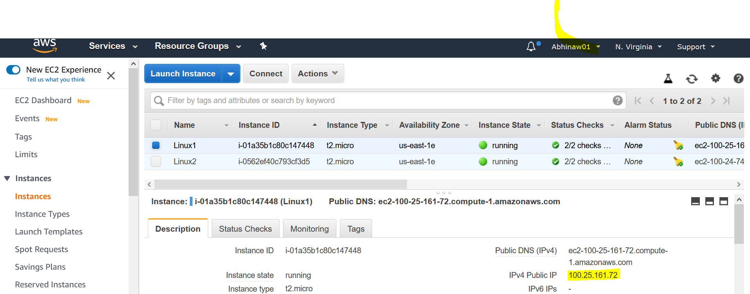

**Deployed html file**

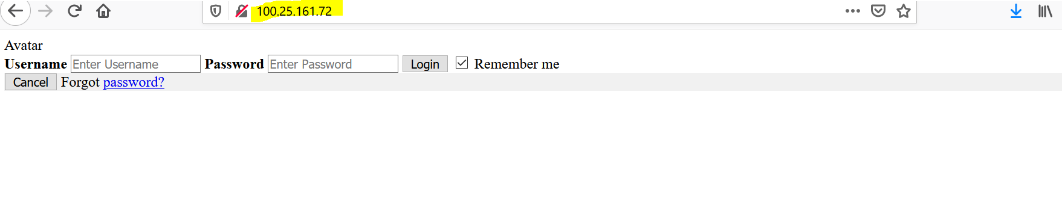

**Linux2**

**Ip Address :100.24.74.82**

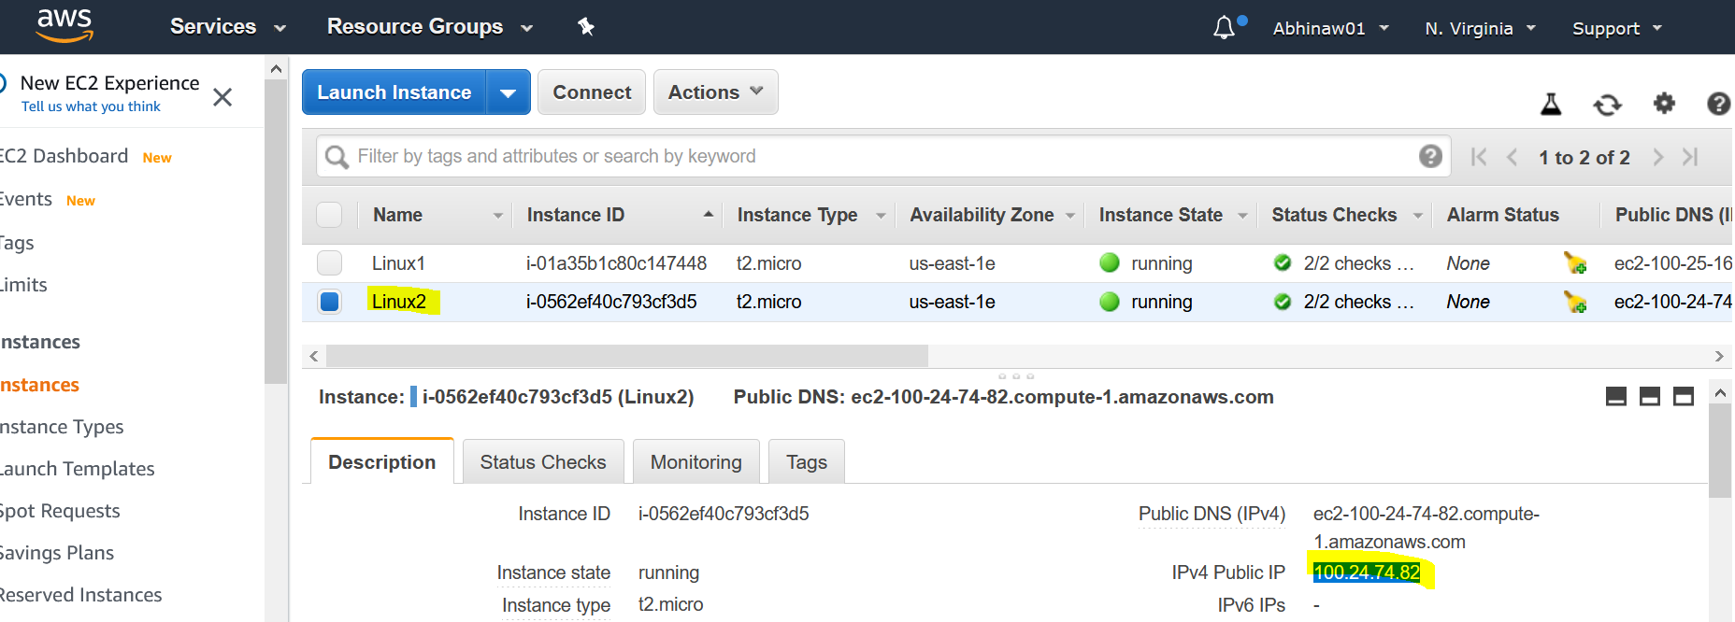

**Deployed html file to another Linux server with some changes in Lebel**

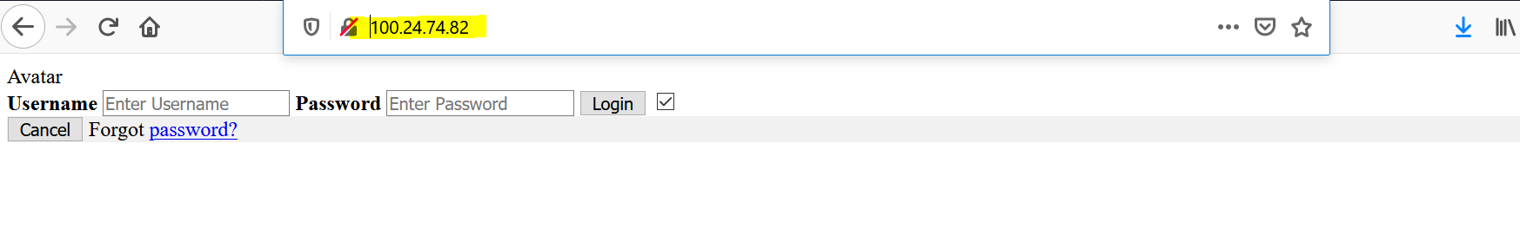

**MY LOAD BALANCER:**

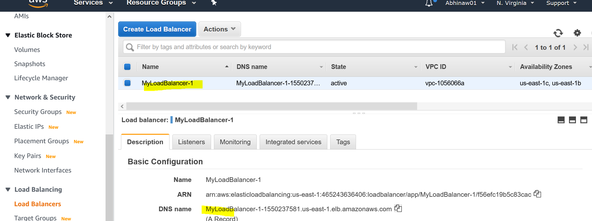

**My Target groups**

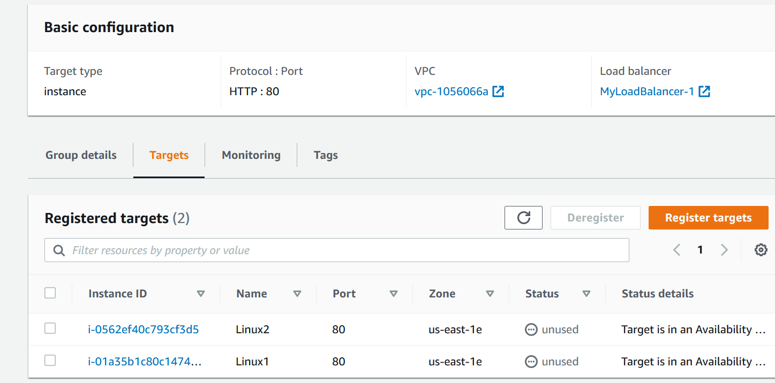

**Load Balancer still not activated**

* **I am trying to get this fixed hopefully It will be fixed soon.**

